MGMS - Settings

Functional Specification Document

Ver. 1.8

Version History
Date | Description
12-Oct-2010 | First Draft
25-Dec-2010 | Added new tables – eligibility criteria & Proposal category
10-Feb-2011 | Renamed Masters to Settings

Table of Contents

Version History 2
1 Introduction 4
1.1 Purpose 4
1.2 Scope 4
1.3 Assumptions 4
1.4 Constraints 4
2 Menu – Settings 4
2.1 Sub menu- Grant Agency 4
2.2 Sub menu – Account Head 6
2.3 Sub menu – Grant Period 8
2.4 Sub menu – Project type 10
2.5 Sub menu – Attachment Type 10
2.6 Sub menu – PI 11
2.7 Sub menu – Add Role 13
2.8 Sub Menu – Employee Designation 14
2.9 Sub Menu – Salary Component 15
3 Business Rules 16
4 Status Messages 16

Introduction

Purpose

This document provides the requirements and functional specifications for the Multisite Grant Management System project.

This is not a project plan or a design document. It is a guide for system architecture and development, not for phasing, timelines or deliverables.

Finally, this is a ‘living document’ and the specification will change, continuously, as the project proceeds. More details will be added and the existing information edited as the requirements, scenarios and use cases evolve in the course of the project.

Scope

The settings module captures records of all entities which are to be used by the GMS institution users in the day-to-day operations. As new functional modules are planned and designed, more of these sections are added in Settings. The system administrator is ideally expected to create and maintain records in this module.

Assumptions
Currently, it has been decided to use the same settings across institutions especially finance related entities. This is in order that there is smooth flow of control and data when there are transactions involved. Where strictly institution wise options are needed, the changes will be made as appropriate.

Constraints

A super admin may be required and need to be planned, for each network of institutions using the MGMS.

Menu – Settings

Sub menu- Grant Agency

Figure 1: Create Grant Agency
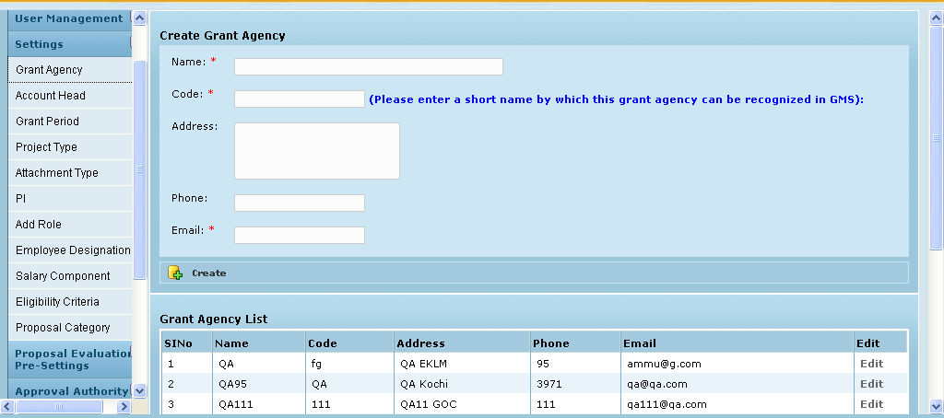

Field /Label | Input-Control | Data Type | Remarks/Edit Check
Create Grant Agency
Name | Textbox | String | Required
Code | Textbox | String | Required; a short name by which this agency can be recognized in GMS
Address | Textarea | String | Required
Phone | Textbox | String | Required
Email | Textbox | String | Required
Active | Listbox | char(1) | Required
Create | Button
Grant Agency List
(table fields)
SlNo | Auto populated
Name | Auto populated
Code | Auto populated
Address | Auto populated
Phone | Auto populated
Email | Auto populated
Active | Auto populated
Edit | Link |  | Opens the page shown in Fig 2

Edit Grant Agency
Figure 2: Edit Grant Agency
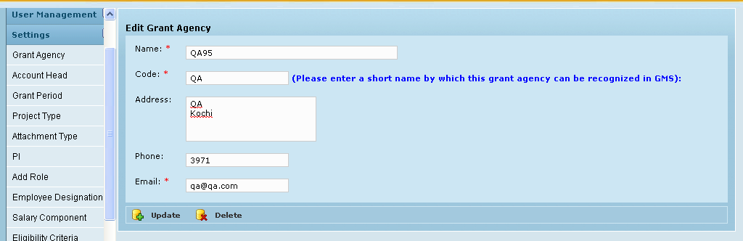

Field /Label | Input-Control | Data Type | Remarks/Edit Check
Edit Grant Agency
Name | Textbox; Auto populated & editable | String | Required
Code | Textbox; Auto populated & editable | String | Required; a short name by which this agency can be recognized in GMS
Address | Textarea; Auto populated & editable | String | Required
Phone | Textbox; Auto populated & editable | String | Required
Email | Textbox; Auto populated & editable | String | Required
Active | Listbox; Pre-selected & editable | char(1) | Optional
Update | Button
Delete | Button

Sub menu – Account Head

Figure 3: Create Account head
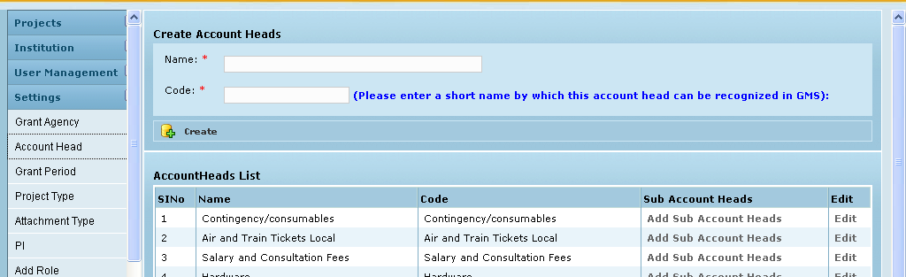

Field /Label | Input-Control | Data Type | Remarks/Edit Check
Create Account Heads:
Name | Textbox | String | Required
Code | Textbox | String | Required; a short name by which this account head can be recognized in GMS
Create | Button
AccountHeads List
SlNo | Auto populated
Name | Auto populated | String
Code | Auto populated | String
Active | Auto populated | char(1) | Optional
Sub Account Heads | “Add Sub Account heads” | Link | Opens page shown in Fig 4
Edit | “Edit” link |  | Opens page shown in Fig 5

Add Sub Account heads

Figure 4: Add Sub Account heads
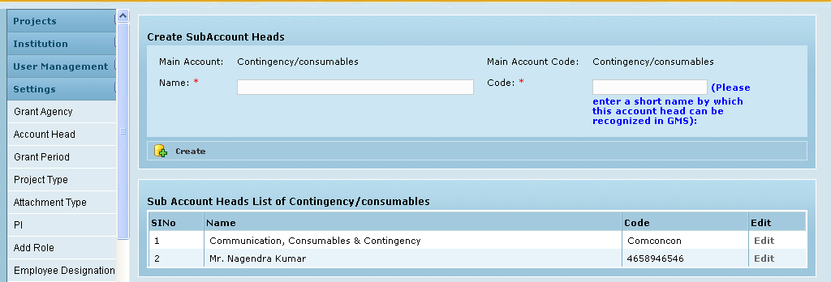

Field /Label | Input-Control | Data Type | Remarks/Edit Check
Create Account Heads:
Main Account | Auto populated
Main Account Code | Auto populated
Name | Textbox; | String | Required
Code | Textbox; | String | Required; a short name by which this sub account head can be recognized in GMS
Create | Button
Sub Account Heads List of <Main Account Code>
Sl No | Auto increment for each line item
Name | Auto populated
Code | Auto populated
Edit | Link |  | Opens page where sub account head details can be updated and also deleted

Edit Account Heads

Figure 5: Edit Account head
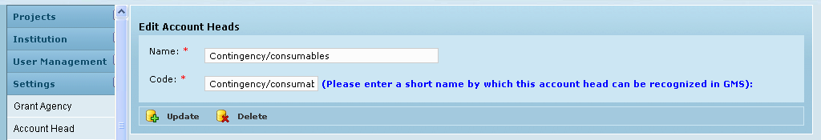

Field /Label | Input-Control | Data Type | Remarks/Edit Check
Create Account Heads:
Name | Textbox; Auto populated & editable | String | Required
Code | Textbox; Auto populated & editable | String | Required; a short name by which this sub account head can be recognized in GMS
Active | Listbox; Pre-selected & editable | char(1) | Optional
Update | Button
Delete | Button

Sub menu – Grant Period

Figure 6: Create grant period
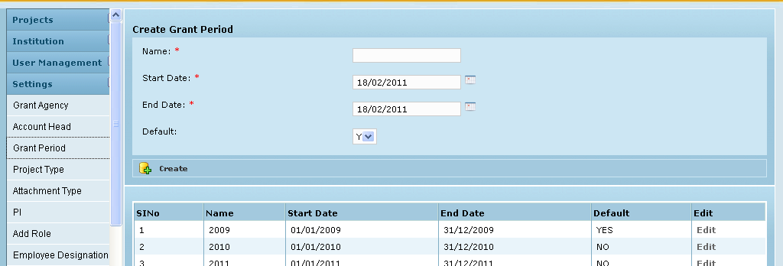

Field /Label | Input-Control | Data Type | Remarks/Edit Check
Create Grant Period
Name | Textbox | String | Required
Start Date | Calendar | Date | Required
End Date | Calendar | Date | Required
Default | Listbox | char(1) | Required
Create | Button
SlNo | Auto populated
Name | Auto populated | String
Start Date | Auto populated | Date
End Date | Auto populated | Date
Default | Auto populated | char(1)
Edit | “Edit” link

Edit

Figure 7: Edit grant period
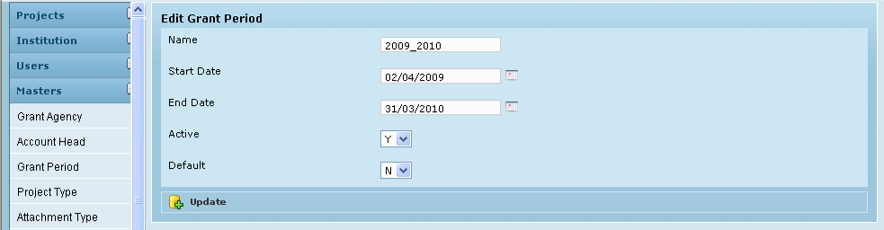

Field /Label | Input-Control | Data Type | Remarks/Edit Check
Edit Grant Period
Name | Textbox; Auto populated & editable | String | Required
Start Date | Calendar; Auto populated & editable | Date | Required
End Date | Calendar; Auto populated & editable | Date | Required
Default | Listbox; Pre-selected & editable | char(1) | Required
Update | Button

Sub menu – Project type

Figure 8: Create Project Type
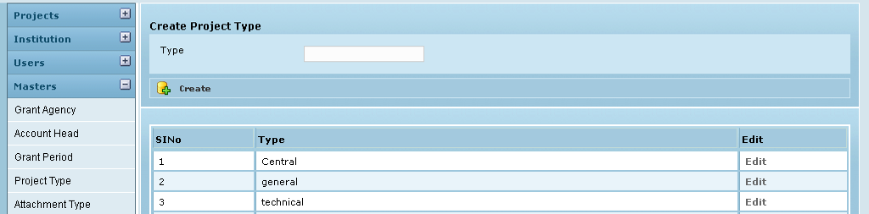

Field /Label | Input-Control | Data Type | Remarks/Edit Check
Create Project Type
Type | Textbox | String | Required
Create | Button
SlNo | Auto populated
Type | Auto populated | String
Edit | “Edit” Link

Edit

Figure 9: Edit Project type
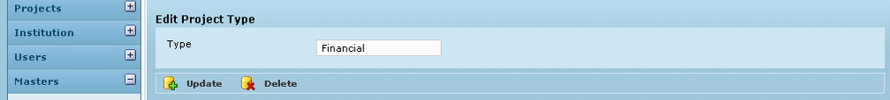

Field /Label | Input-Control | Data Type | Remarks/Edit Check
Edit Project Type
Type | Textbox; Auto populated & editable | String | Required
Update | Button
Delete | Button

Sub menu – Attachment Type

Figure 10: Create Attachment type
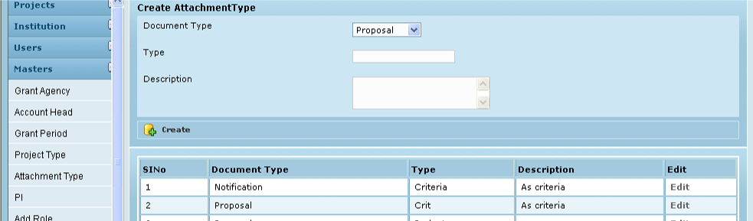

Field /Label | Input-Control | Data Type | Remarks/Edit Check
Create Attachment Type
Document Type | Listbox | String | Required
Type | Textbox | String | Required
Description | Textarea | String
Create | Button
SlNo | Auto populated
Document Type | Auto populated | String
Type | Auto populated | String
Description | Auto populated | String
Edit | “Edit” link

Edit

Figure 11: Edit Attachment type
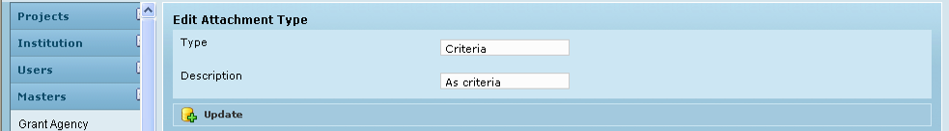

Field /Label | Input-Control | Data Type | Remarks/Edit Check
Edit Attachment Type
Type | Textbox; Auto populated & editable | String | Required
Description | Textarea | String
Update | Button

Sub menu – PI

Figure 12: Create Principal Investigators (PI)
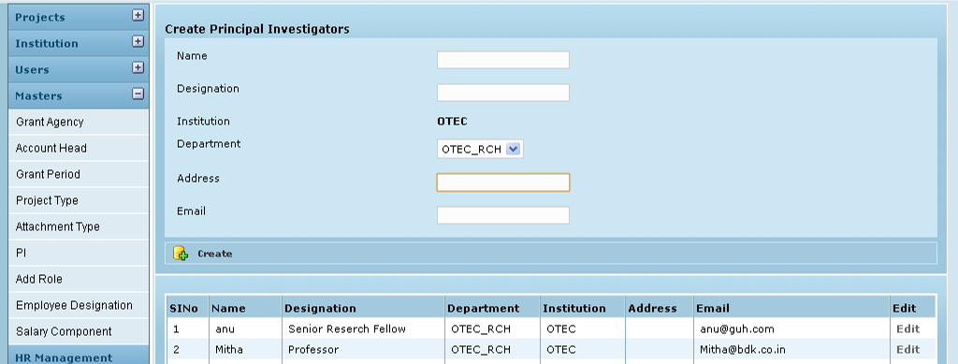

Field /Label | Input-Control | Data Type | Remarks/Edit Check
Create Principal Investigators
Name | Textbox | String | Required
Designation | Textbox | String
Institution | Auto populated | String
Department | Listbox; preselected & editable | String
Address | Textbox | String
Email | Textbox | String | Required
Create | Button
(table fields)
Name | Auto populated | String
Designation | Auto populated | String
Institution | Auto populated | String
Department | Auto populated | String
Address | Auto populated | String
Email | Auto populated | String
Edit | “Edit” link

Edit Principal Investigators

Figure 13: Edit PI
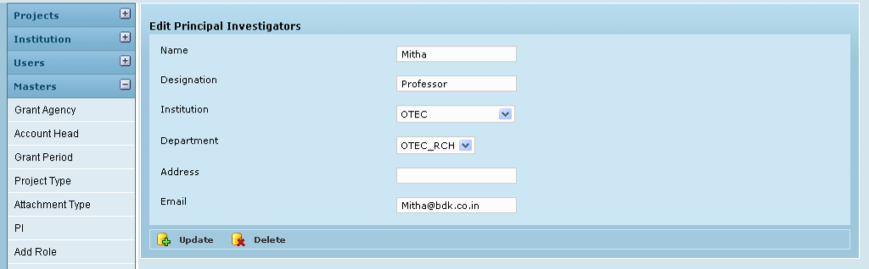

Field /Label | Input-Control | Data Type | Remarks/Edit Check
Edit Principal Investigators
Name | Textbox; Auto populated & editable | String | Required
Designation | Textbox; Auto populated & editable | String
Institution | Listbox; preselected & editable | String
Department | Listbox; preselected & editable | String
Address | Textbox; Auto populated & editable | String
Email | Textbox; Auto populated & editable | String | Required
Update | Button
Delete | Button

Sub menu – Add Role

Figure 14: Create Role
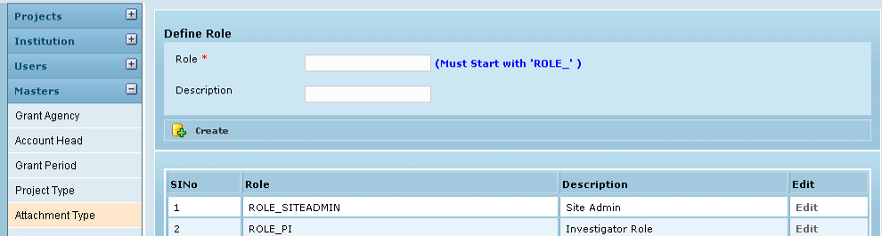

Field /Label | Input-Control | Data Type | Remarks/Edit Check
Define Role
Role * | Textbox | String
Description | Textbox | String
Create | Button
(table fields)
SlNo | Auto populated
Role | Auto populated | String
Description | Auto populated | String
Edit | “Edit” link

Edit Role

Figure 15: Edit Role
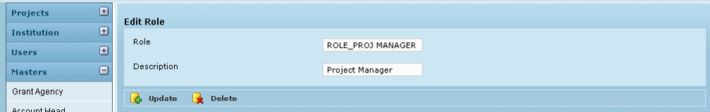

Field /Label | Input-Control | Data Type | Remarks/Edit Check
Edit Role
Role * | Textbox; Auto populated & editable | String | Required
Description | Textbox; Auto populated & editable | String
Update | Button
Delete | Button

Sub Menu – Employee Designation

Figure 16: Create Employee designation
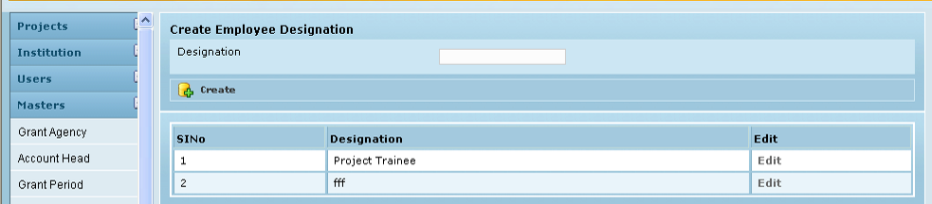

Field /Label | Input-Control | Data Type | Remarks/Edit Check
Create Employee Designation
Designation | Textbox | String | Required
Create | Button
SlNo | Auto populated
Designation | Auto populated | String
Edit | “Edit” Link

Edit

Figure 17: Edit Employee designation
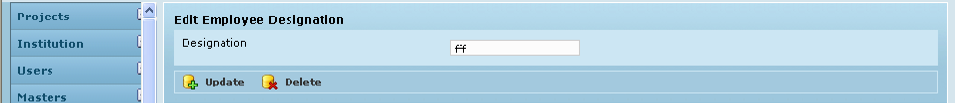

Field /Label | Input-Control | Data Type | Remarks/Edit Check
Edit Employee Designation
Designation | Textbox | String
Update | Button
Delete | Button

Sub Menu – Salary Component

Figure 18: Create Salary component
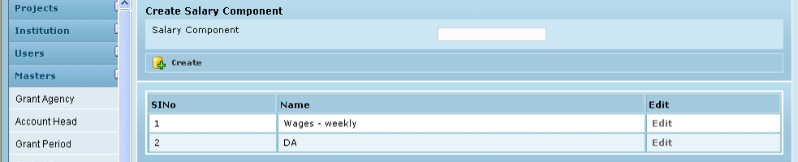

Field /Label | Input-Control | Data Type | Remarks/Edit Check
Create Salary Component
Salary Component | Textbox | String | Required
Create | Button
(table fields)
SlNo | Auto populated
Name | Auto populated | String
Edit | “Edit” Link

Edit Salary Component

Figure 19: Edit Salary component
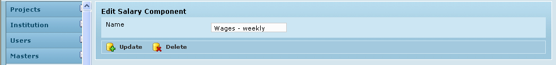

Field /Label | Input-Control | Data Type | Remarks/Edit Check
Edit Salary Component
Name | Textbox; Auto populated & editable | String
Update | Button
Delete | Button

Business Rules

Validation is required to avoid duplication of entities – the checking can be done against the code – for e.g agency, account head or directly against the name – for e.g. designation, role, salary component.

Currently , irrespective of the institution where an entity was created, it should be available across institutions, for use. For e.g. if Manager role is created in institution ABC, it should be available for all institutions in GMS

Currently any codes requested of the user are expected to be a familiar shorter name and the instruction for user is to be displayed beside the field.

Status Messages

Sl No | Status Message
1 | Created Successfully
2 | Updated Successfully
3 | Deleted Successfully
4 | The Requested Record Not Found
5 | The Record can't be deleted, Already in use
6 | The Record Already Exists
7 | Please Enter a valid email address
8 | You can not delete yourself, please login as another admin and try again
9 | This e-mail id already exists
10 | An Investigator already exists with the same name

